- You can access HR Trainings from the TalentWorks Welcome Page at https://lacounty.csod.com Or Click on DMH website: Default , then on Applications

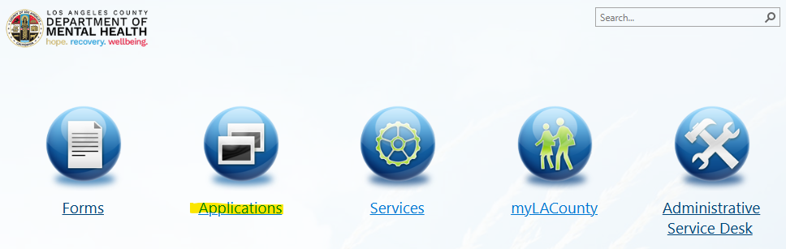

- Click on Cornerstone TalentWorks

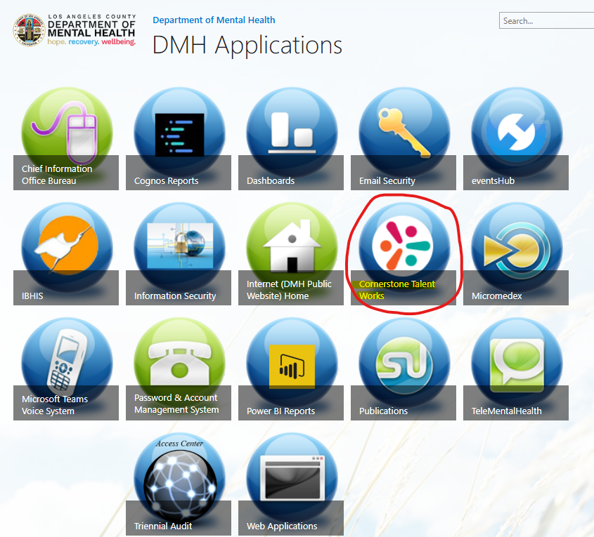

- When you click at the Cornerstone TalentWorks site, you will see the Welcome screen below. To access trainings or transcripts you can click on the orange “Learning” tab, or you can click “My Learning Transcripts” and this will display all the trainings you have completed and those needed to be completed. Trainings may also appear under the “My Learning Transcript” tab and you can Launch the trainings from there as well.

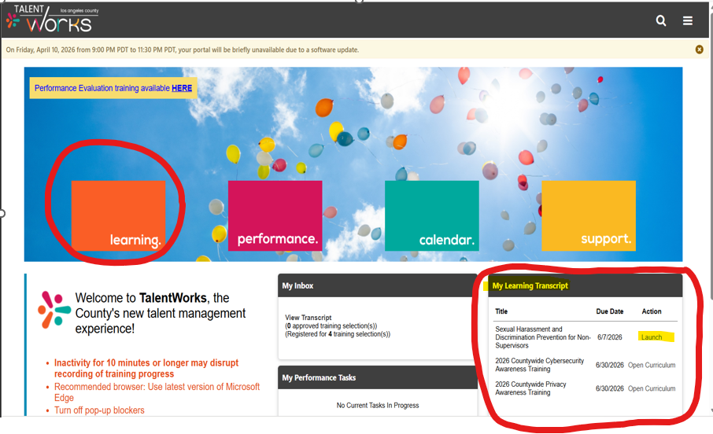

- When you click on the “Learning” tab you will see the page below.



