In the Agent Assist Application click on Medi-cal in the Drop-down menu
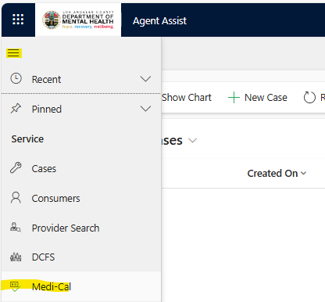
Then click on “Login to Provider Portal”
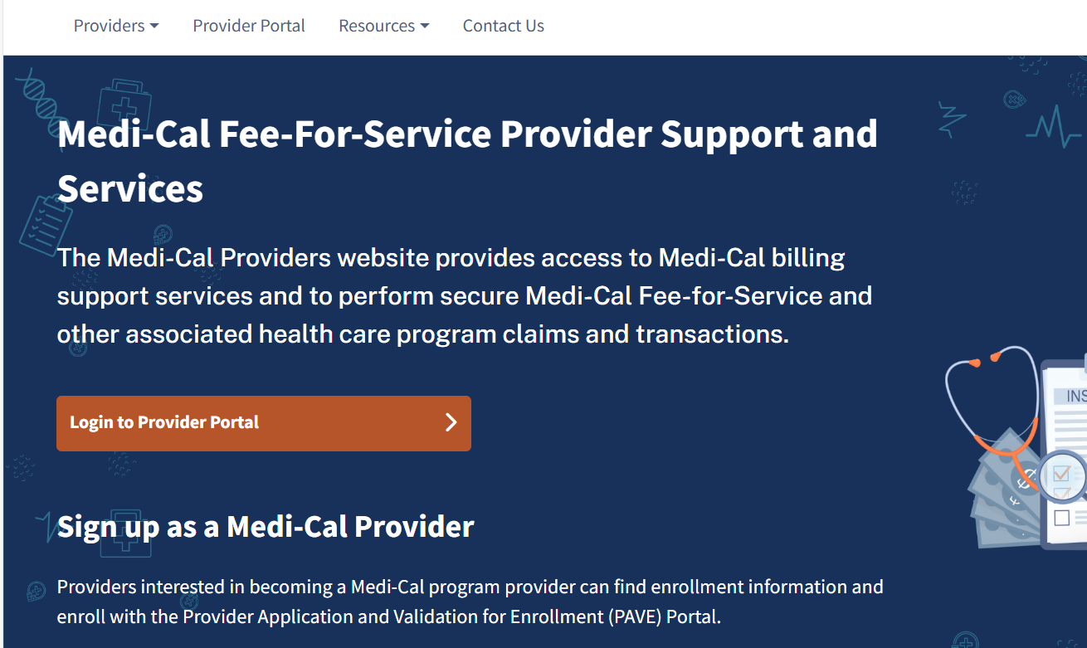

Next enter your e-mail to create new password and pin. If you already have a password, click on “Log in” and fill in the information requested.
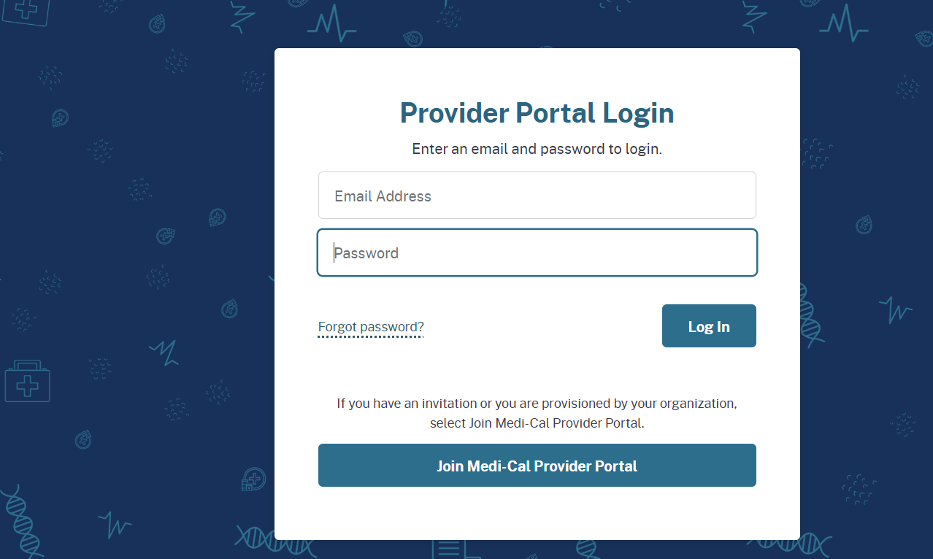
Click on I confirm Box, then Next
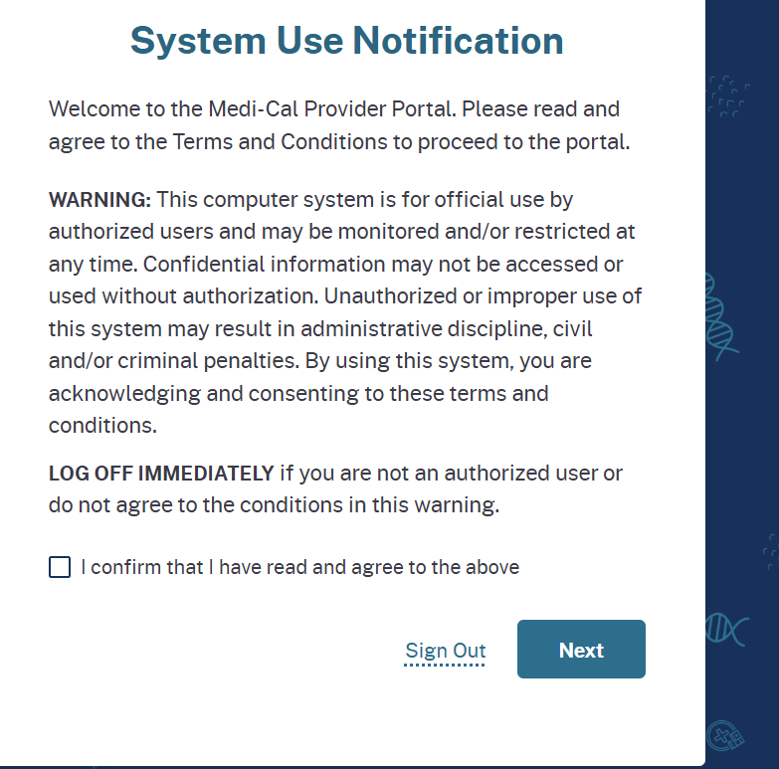
Click on Single Subscriber
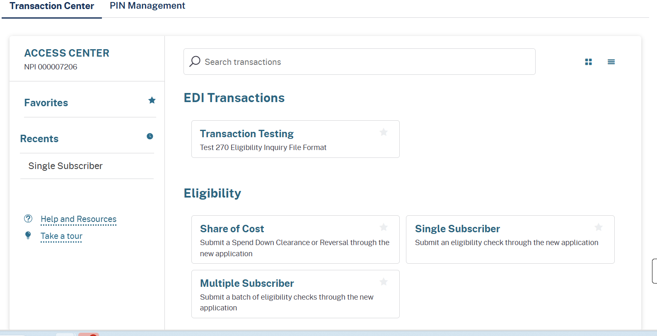
Fill in information for:
Subscriber ID – Social Security or Medical Number
Subscriber Birth Date
Issue Date and Service Date- This is the day you are checking the Medical Status



